Standard 15: Accessibility of School Buildings

Halton District School Board Accessibility Plan
The Halton District School Board is committed to ensuring our premises, programs and resources are accessible to all students and staff with our Halton District School Board’s Accessibility Plan.
During the spring 2009 through to fall 2009, Harrison Consulting was hired to perform an accessibility audit on all our schools, J. W. Singleton Education Centre and New Street Education Centre. It is this report that guides our facility renovations to accommodate the needs of our students and staff with disabilities:
To further increase awareness of supporting members of the general public, including our parents/guardians with disabilities, the Accessibility for Ontarians with Disabilities Act Customer Service regulation focusing on inclusive, respectful language and ways of interacting with people with disabilities is addressed in the Creating a Culture of Accessibility, 2010 booklet. The booklet was vetted by a variety of persons and groups in Halton.
Many of our schools have been renovated to improve accessibility with the inclusion of automatic door openers on school interior and exterior doorways, elevators in most schools with multiple stories, ramps for school front and rear access points, accessible washrooms, parking spaces designated with people with disabilities and renovations to some schools to accommodate track lifting for students with physical disabilities, to name a few.

Suggestions for Parents/Guardians with Accessibility Concerns
Parents/Guardians registering their child at school are encouraged to speak to the Principal about any accessibility concerns they might have for their student. The Principal will then in turn involve the necessary resource staff to evaluate the accessibility concerns and propose options for consideration.
If a student requires specialized accessible transportation, parents/guardians are asked to let the School Principal know when registering their child. The Principal will work with both the Student Services and Transportation to make the necessary arrangements.
If parents/guardians have other concerns with respect to accessibility i.e.: daily routines in the school building, the instructional program, their child entering or exiting the building safely, drop off or pick up in designated parking spots, etc…. they are encouraged to contact the classroom Teacher or Principal of the school. School staff are happy to work with parents/guardians to resolve these concerns.
The Accessibility for Ontarians with Disabilities Act has established Integrated Accessibility Standards, which summarizes specific standards and timelines for School Boards to meet with respect to accessibility including disability training for staff. The Ontario Education Services Corporation (OESC) who are on contract with the Ministry of Education to help boards put the Integrated Accessibility Standards Regulation 191/11 in place, supported the development of a richrange of supports that will help teachers and other classroom staff “include accessibility issued in the everyday learning of the classroom.” Model lessons that follow the Ontario curriculum as used in English-language school boards have been written by practising teachers to provide ready-to-use resources.
The following chart shows an implementation timeline for the Integrated Accessibility Standards.
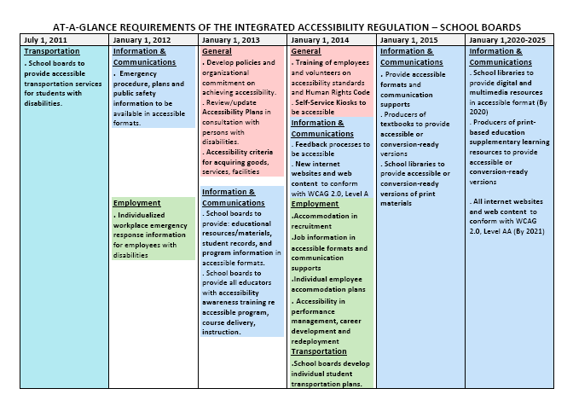
Online training is provided for all staff and volunteers on the Ontario Human Rights Code.
In addition, all new schools built in the Halton District School Board are accessible to persons with physical disabilities and environmental hypersensitivities.
In accordance with the Accessibility for Ontarians with Disabilities Act 2005, the Halton District School Board has an Accessibility Coordinating Committee, including representation from the Student Services Department and SEAC. The Halton District School Board Multi-Year Accessibility Plan is reviewed and modified annually.
The following charts outline the accessibility status of all schools and Education Centres in the Halton District School Board as of June 2013. These charts will be updated by the Facilities Department in the near future.

