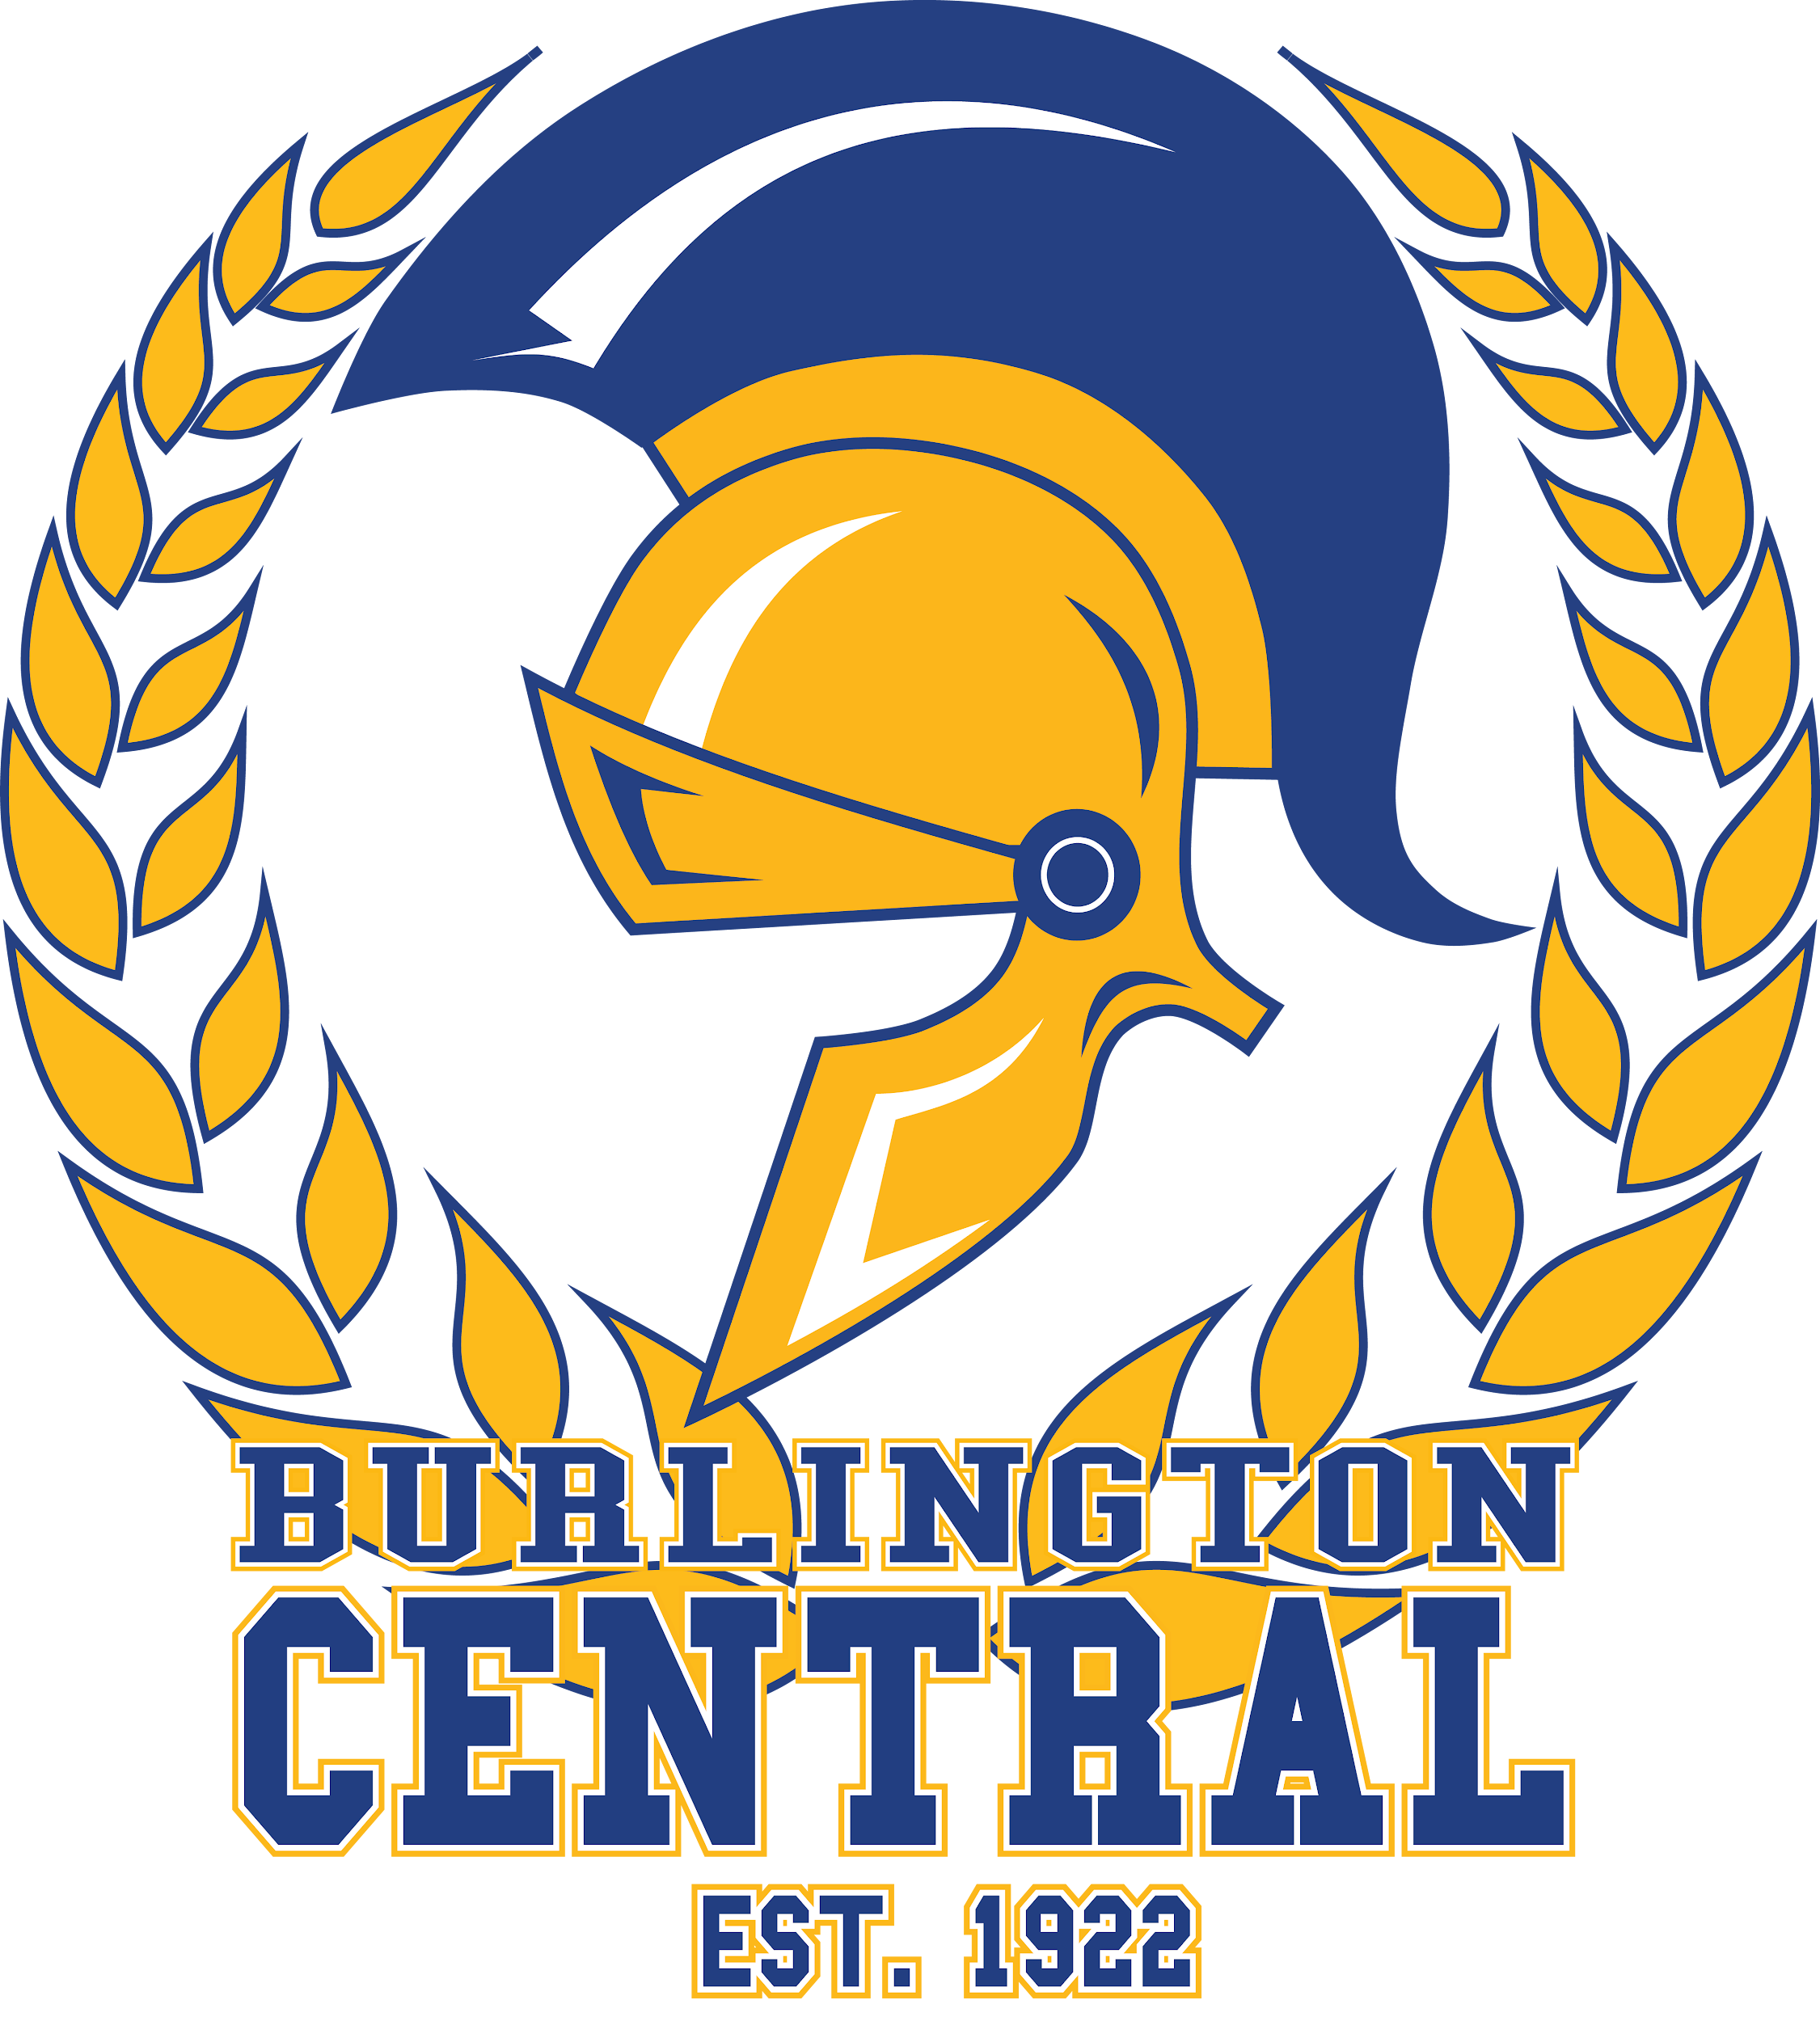

Arts & Culture SHSM

Registration & Consent Form

First Name |  |  | Last Name
Grade |  |  | Age
Pathways  (Circle one) | College | Apprenticeship | University | Workplace
Student Email |  |  | Guardian Email
Student cell |  |  | Guardian Cell
Home School |  |  | Career Goal

Arts & Culture SHSM students who complete the requirements for the Ontario Secondary
School Diploma and ALL the SHSM requirements will receive an OSSD with the SHSM Seal.

Requirements for SHSM Seal:

  - 4 Major Credit Courses (a minimum of 1 credit in both Grades 11 and 12)
  - Industry Certification and Training (a minimum of 6)
  - Reach-ahead and Career Exploration Activities (Exploration of post-secondary options)
  - Sector Partnered Conceptualized Experience (1 day experiential opportunity)
  - Two Co-op credits (can be Summer or during the school year)

Your signature below (both student and parent/guardian) will indicate your permission for Student Services to officially enrol you into the Arts & Culture Specialist High Skills Major program. This will also allow Student Services to make any necessary timetable adjustments.

I, _______________________________________ give permission for my son/daughter to enrol in the
^{Please print (Guardian name)}
Arts & Culture Specialist High Skills Major Program at Burlington Central H.S.
Student’s Signature: _______________________ Date:______________________

Guardian’s Signature:______________________ Date:______________________

Office Use Only
- Accepted
- Aspen

Please return this form to:
Mr. Moran, Student Services Date Received:_________________________

BCHS Arts & Culture SHSM Planner

Arts & Culture  Specialist High Skills Major Credits  -Complete 4 credits  -a minimum of 1 credit in both Grades 11 and 12  -1 of these 4 credits may be substituted by an additional cooperative education credit related to the sector (additional to the 2 required co-op credits) | Grade 11 | Grade 12
 | Arts & Culture Major Credits  ❏ ADA3M (Dramatic Arts)  ❏ AMC3O (Music for Creating)  ❏ AMG3O (Guitar)  ❏ AMM3O (Music and Computers)  ❏ AMV3O/M (Vocal Music)  ❏ ASM3O (Media Arts)  ❏ AVI3O/M (Visual Arts)  ❏ AWA3O/M (Crafts)  ❏ ICS3C/U (Comp. Prog. & Game Design)  ❏ TGV3M (Technical Theatre)  (Select at least one for each grade) | Arts & Culture Major Credits  ❏ ADA4M (Dramatic Arts)  ❏ ADV4M (Film & Video)  ❏ ASM4E/M (Media Arts)  ❏ AVI4E/M (Visual Arts)  ❏ EWC4C/U (Writer’s Craft)  ❏ TGV4M (Technical Theatre)  ❏ ICS4C/U (Comp. Programming)  (Select at least one for each grade)
Business or Canadian &  World Studies credit* (CLA unit)  -Complete 1 credit  -may be substituted by an additional cooperative education credit related to the sector (additional to the 2 required co-op credits) | Business Focus  ❏ BAF3M (Accounting)  ❏ BMI3C (Marketing)  ❏ MEL3E (Mathematics for Everyday Life)  Canadian & World Studies Focus  ❏ CHW3M (World History to the 16th C.)  ❏ CLU3M (Law) | Business Focus  ❏ BAT4M (Accounting)  ❏ BBB4M (Intro to International Bus.)  ❏ BOH4M (Business Leadership online*)  ❏ CIA4U (Economics)  Canadian & World Studies Focus  ❏ CHI4U (Canadian History)  ❏ CLN4U/C (Law)  ❏ CHY4U (World History)  Guidance & Career Education  ❏ GLE4O/GLS4O (Learning Strategies)
English  (*CLA in Grade 12) | English  - NBE/ENG3C (English - College)  - NBE/ENG3E (English - Workplace)  - NBE/ENG3U (English - University) | English*  - ENG4C (English - College)  - ENG4E (English - Workplace)  - ENG4U (English - University)
Internship Experience  (Select at least one) | A 2-credit co-op placement in an Arts & Culture sector-related business/organisation, linked to a course in the SHSM major credit bundle or GLC2O - Grade 10 Career Studies.  - COP3O8 (Co-op) Grade 11  - COP4O8 (Co-op) Grade 12  - Summer Co-op (Grade 11 Summer July - full day)  - Night School Co-op (Semester 1 or Semester 2)

Grade 11 SHSM Course Planning | Grade 12 SHSM Course Planning
- English:  - SHSM Major 1  - SHSM Major 2  - Business or Canadian &World Studies | - English:  - SHSM Major 3  - SHSM Major 4  - Business or Canadian &World Studies

