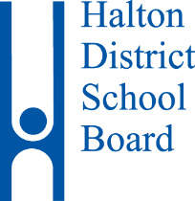

TIMELINE FOR

HDSB PRINCIPAL

Friday August 25, 2017 | Ad and application packages posted internally and on the Halton District School Board website
Monday September 11, 2017  7:00 p.m. - 8:30 p.m. | Information session at Garth Webb Secondary School  2820 West Oak Trails Blvd, Oakville in the Library
Tuesday September 19, 2017 | Applications must be received by electronic submission  no later than 12:00 p.m.
Wednesday September 20 - Thursday October 5, 2017 | Packages reviewed and pre-interview reference check process completed
Friday October 6, 2017 | Applicants informed of interview times and locations
Tuesday October 10 -  Friday October 20, 2017 | Interviews will take place
Tuesday October 24, 2017 | Post-interview reference check process completed
Wednesday November 15, 2017 | Report to Halton District School Board  Candidates informed of outcome by phone call in evening

